**MS Access**

**Class 8**

**Lab Tutorial 29**

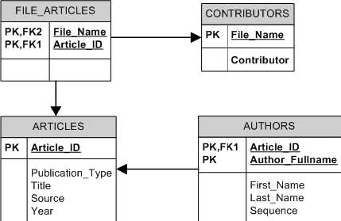

## Observe the table very carefully. Note down the relationships among the tables.